The Florence Nightingale Academy
RE Policy

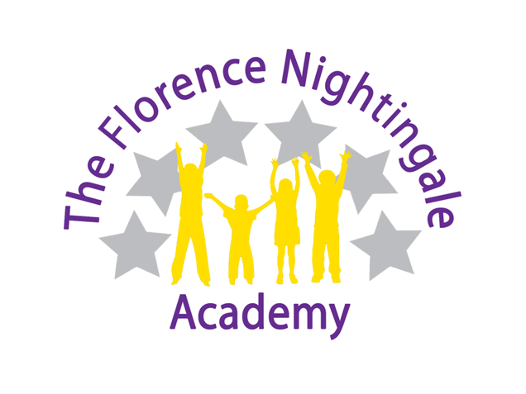

RE Coordinator – Mrs Whittaker

2022 - 2023
Rationale
We want our children to feel the ‘buzz’ of RE. We want our children to have no limits to what their aspirations and ambitions can be. For them to grow up wanting to be writers, journalists, outreach workers, charity officers or curators. Through our high-quality RE education, we help our children to gain a coherent knowledge and understanding of religions and world views. We want to enhance their curiosity and prepare them to ask perceptive questions, think critically, develop respect and tolerance and gain a knowledge of their own identity, belonging and diversity. We want our children to remember their RE lessons in our school, to cherish these memories and embrace the opportunities they are presented with.
Aims
- To have mutual tolerance and respect for all members of their community along with a respectful attitude to those of different faiths and beliefs to their own.
- To be able to share ideas and experiences within fair and trusting environments.
- To have knowledge of their own identity, belonging and diversity.
- To have knowledge and understanding of Christianity and other principle religions represented in Nottinghamshire and Great Britain.
- To know the issues with and between faiths to help them understand and respect different religious beliefs, values and traditions.
- To develop their ability to make reasoned and informed judgements about religious and moral issues, with reference to the teachings of principle religions.
Curriculum
As a whole school we have agreed to adopt the Nottinghamshire’s Religious Education Agreed Syllabus 2015-2020. The aim of RE in Nottinghamshire is to ensure all pupils:
- Know about and understand a range of religions and world views.
- Express ideas and insights about the nature, significance and impact of religions and world views.
- Gain and deploy the skills needed to engage seriously with religions and world views.
(Taken from RE for All – The Agreed Syllabus for RE in Nottinghamshire 2015 - 2020)
Foundation Stage 1
In foundation stage 1, children will have opportunities to find out and learn about the world they live in. Such experiences include:
- Learning about their culture and the belief of others.
- Sharing the celebration of different festivals.
- Hearing stories from a variety of cultural and religious traditions.
- Using the Nursery provisions to enable playful RE.
Foundation Stage 2
In addition to this, foundation stage 2 children will follow the Nottinghamshire’s Agreed Syllabus for Religious Education 2015-2020 alongside the Early Years Foundation Stage Curriculum. Teaching RE requires a multi-sensory approach, providing opportunities for pupils to learn and understand about themselves, others (PSED) and the word (UW) and to develop pupil’s abilities to express themselves (CL and EAD).
Key Stage 1
The Focus of RE for KS1 enables children to develop their knowledge and understanding of religions and world views. They find out about simple examples of religion that are drawn from local, national and global contexts. They use basic subject specific vocabulary. They raise questions and begin to express their own views in response to the material they learn about and in response to questions about their ideas.
- Children will study Christianity, Islam and Judaism.
Key Stage 2
The Focus of RE for KS2 enables pupils to extend their knowledge and understanding of religions and world views, recognising their local, national and global contexts. They are introduced to an extended range of sources and subject specific vocabulary. They are encouraged to be curious and to ask increasingly challenging questions about religion, belief, values and human life. Pupils learn to express their own ideas in response to the material they engage with, identifying relevant information, selecting examples and giving reasons to support their ideas and views.
- Children will study Christianity, Islam, Judaism, Hinduism, Sikhism and Buddhism.
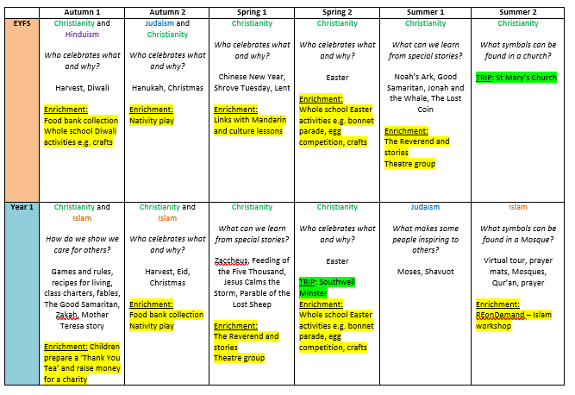
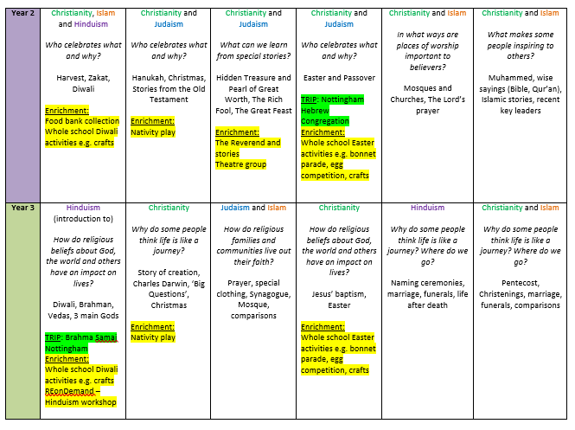
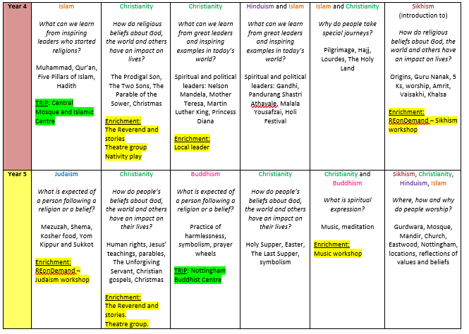
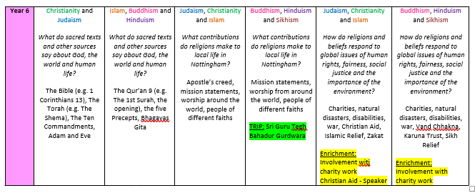
Curriculum Progression
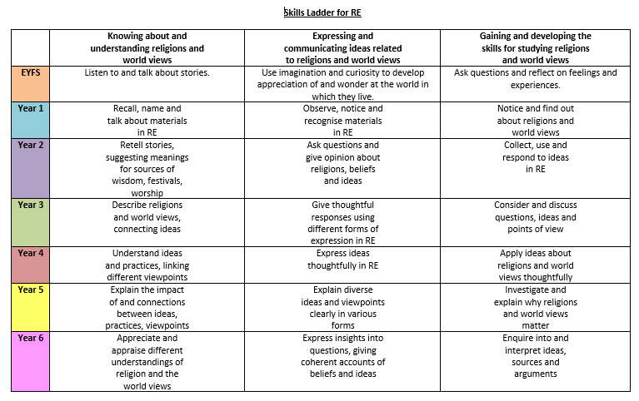

Teaching and Learning
We use a variety of teaching and learning styles in RE lessons. Our pedagogy is based on research conducted by Rosenshine and his principles of instruction (2012).
RE Delivery Document
Intent | We take the Nottinghamshire RE Agreed Syllabus statements and provide any enhanced version of this. We map these in a coherent and sequential progression model that outlines the knowledge, skills and vocabulary needed at each stage that will build to clearly defined end points. Teachers take the progression grid and map this into a long-term plan for their year group. Teachers then plan at a more detailed level the sequencing of content to be taught across each unit.
Implementation | Ensure that the teachers of the subject have excellent subject knowledge, and leadership supports that acquisition of this for NQT and non- specialist teachers. Subject matter is presented clearly, teachers carefully check learning and identify misconceptions, providing direct feedback. Teaching is designed to ensure children know more and remember more. RE is carefully resourced to ensure we have all the specialism and resources required.
Impact | Learners develop detailed knowledge and skills. We check this through regular pupil voice and collecting evidence of outcomes which we measure against our age base progression grids. Pupils are well prepared at each stage to be ready for the next stage of learning.

Working Memory to Long Term Memory
All staff use Rosenshine’s principals in action when planning and delivering lessons.
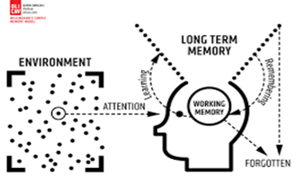
Strategies identified | What do we expect to see in our RE lessons?
Regular review | Academic or subject vocabulary that has been taught will be modelled throughout teaching. Teachers will revisit prior knowledge (previous year group/lesson).
Present new materials using small steps | RE planning ensures achievable and repeated steps are provided to build children’s confidence, competence and retention.
Ask questions (Blooms Taxonomy) | Questions help children practice new information and connect new material to their prior learning. The teacher will question children around the specific knowledge and vocabulary they have using in this topic as well as others.
Provide models | Expert teachers/peer models identified in the lesson will exemplify the specific skills/knowledge required for the task.
Guide student practice | Teachers will spend more time guiding children’s practice of new material. It will be forgotten unless time is given for rehearsal we revisit tasks over and over again, allowing children lots of time to practice. This is always guided and supported by expert teaching.
Check for children’s understanding | Checking understanding at each point can help children learn the material with few errors. We would expect to see tasks/skills broken down into very small chunks, with regular assessment checking from teachers throughout.
Obtain a high success rate | In RE, we would expect to see that a skill is successfully taught before moving on. We take our time to achieve consistent success.
Provide scaffolds for difficult tasks | The teacher provides children with temporary supports and scaffolds to assist them when they learn difficult tasks.
Independent practice | Children should have the opportunity to practice regularly and independently to transfer the knowledge into their long-term memory. In RE lessons there is opportunity for this.
Weekly and monthly review | Children need to be involved in extensive practice in order to develop well connected and automatic knowledge. Weekly reviews can take place in RE lessons, where teachers return to knowledge learned in a previous unit, and following a period of forgetfulness the children use that knowledge again.

This is supported by the six effective learning strategies (Weinstein and Sumeracki 2019) to ensure that all of our children become successful, independent learners who are actively engaged in their own learning.
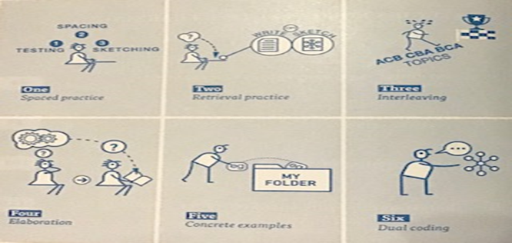

Our principal aim through this pedagogy is to develop the children’s knowledge, skills and understanding in RE. We believe in whole-class teaching methods and combine these with enquiry and skills-based research activities. We believe children should access a variety of activities in lessons such as:
- They have access to, and are able to handle artefacts.
- They go on visits to places of worship.
- They have access to secondary sources such as books and photographs.
- Visitors talk about personal experiences, their faith and culture.
- They listen to and interact with stories.
- They use drama, dance, music and art to retell stories and explore festivals.
- They are shown, or use independently, resources from the internet and videos.
- They are able to use non-fiction books for research.
- They are provided with opportunities to work independently or collaboratively.
We recognise the fact that we have children of differing ability in all our classes, and so we provide suitable learning opportunities for all children by matching the challenge of the task to the ability of the child using our differentiated star challenges. We achieve this through a range of strategies which are differentiated by task, expected outcome and/or support from peers or adults.
Based on combining pedagogy taken from Rosenshine’s principles of instruction and various metacognition strategies RE lessons should follow the following structure:
Review of prior knowledge | -Low stake quizzes using knowledge organisers (within the topic or recapping previous RE topics covered).
Introduce new knowledge and skill for the lesson in small steps taken from Knowledge Statement | -Introduce new knowledge.  -Introduce skill/activity.  -Model using this skill and applying the knowledge.  -Asking questions whilst modelling and lots of discussion.
Practice and apply lesson skill | -Guided practice.  -Children apply skill independently (scaffolding may be required so all children can successfully apply learning).  -Use of AFL and questioning to check student understanding.
Evaluate and reflect upon learning | -What has been our new learning this lesson?  -How have we been successful learners?

Additionally, throughout the week (morning registration/before end of day/lining up) teachers check their children’s knowledge is being retained and transferred in to the long-term memory.
Time Allocation
A minimum of 5% of curriculum time is required for teaching RE.
F2 and KS1: 36 hours per year.
KS2: 45 hours per year.
RE is timetabled weekly for 45 minutes. The children take part in whole school RE afternoons, trips and visitors scheduled throughout the year.
Curriculum Planning
Our curriculum is carefully planned to ensure full coverage of the Nottinghamshire Agreed Syllabus. The topics we have selected are to help strengthen our children’s knowledge and understanding of world religions and views. Our long-term and medium-term plans map out the skills and themes covered each term for each key stage. These plans define what we will teach and ensure an appropriate balance and distribution of work across each term. Topics are reviewed yearly by the subject leader liaising with staff and SLT.

Collective Worship
Collective worship is identified in law separately from RE. It is therefore not part of any agreed syllabus and is not circumscribed by schemes of work or curriculum requirements. As a school, we aim to link collective worship, wherever possible, to work taking place in the classrooms in a flexible and varied way. Some pupils, at the request of their parents or carers, may be withdrawn from collective worship.
Assessment and Recording
The key purposes of assessment in RE are:
- To inform planning and to enable realistic and challenging goals to be set for future learning.
- To facilitate differentiation.
- To aid progression in learning by identifying pupils’ strengths and areas of development.
- To give feedback to the children as soon as possible, and mark work using the school’s Marking Policy.
- To tick the knowledge statements in individual children’s books according to when a child has met the learning objective and this data is collated by class teachers.
- To form the basis of written reports to parents and carers.
- To provide information about the effectiveness of the teaching programme.
Achievement and progression are measured using the three strands:
- Knowing about and understanding religions and world views.
- Expressing and communicating ideas related to religions and world views.
- Gaining and deploying the skills for studying religions and world views.
Effective recording in RE will:
- Show evidence of progress through the key stages.
- Record end of unit attainment in relation to the knowledge statements.
- Be useful in the writing of reports to parents and carers.
- Enable the transition of information from one teacher to another.
Promoting links with RE and Reading
We ensure that we promote a love of reading across all our subjects. We ensure that the children understand how we are always using our reading skills and how this builds upon phonic skills taught in EYFS. In our RE lessons we access a wide variety of texts that children may need to decode and apply the skills taught in our phonics programme. Religious texts also make greater linguistic demands than modern texts: they include vocabulary not used today, and have more complex sentence structures. These texts would then require children to infer meaning of such new vocabulary and leads to an increase in the richness and breadth of children's vocabulary.
Monitoring
Monitoring takes place regularly through sampling children’s work, and teacher planning, through book looks, pupil voice and lesson observations.

Roles and Responsibilities
- Take the lead in the development of the policy and schemes of work to ensure progression, quality and continuity of the teaching of RE.
- Support staff in their planning and its implementation.
- Support colleagues in monitoring progress.
- Order, maintain and store resources effectively.
- Keep updated about new developments and inform colleagues.
Resources
Resources and artefacts can be found in the Lower Hall. We have a wide range of technology to access the internet as a class. Visits are planned to enhance learning and real-life experiences. Visitors connected with a faith or culture can be invited into school to work with the children.
Knowledge Statements
Our knowledge statements outline curriculum coverage for each topic and ensure full coverage of the Nottinghamshire Agreed Syllabus.
They contain information of prior curriculum knowledge that the children have learnt throughout their primary curriculum to enable staff to support the children to make links to their prior knowledge.
They help to show links between RE enquiry through their question approach topic names e.g. Why do people take special journeys?
All learning objectives are also devised in a question format to structure all lessons to follow an enquiry approach. This allows our children to describe and understand the beliefs and practices before being able to express and communicate their ideas to the question.
Knowledge statements outline key vocabulary to be taught within each topic to help address our whole school focus of narrowing the vocabulary gap.
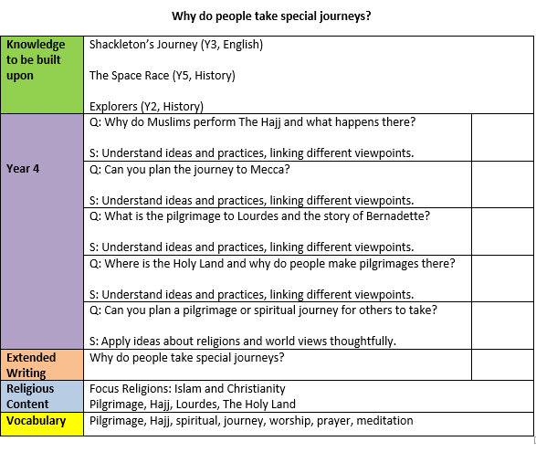
Knowledge Organisers
For students to succeed in a particular area, they must have a foundation of factual knowledge, understand those facts in the context of a conceptual framework and organise knowledge in order to facilitate retrieval and application (Bransford et al., 2000).
We use knowledge organisers to support each topic. Through analysing various studies and research, we want them to support our RE curriculum in the following way:
-Allow children at the start of the topic to see the learning journey that we will be completing.
-Allow children to make links between previous knowledge that links to the new topic we will be undertaking.
-Outline key knowledge that will be covered throughout the topic.
-Support low-stake quizzes at the start of each lesson through regular retrieval of the information outlined.
-Children to refer to the vocabulary outlined on them to help minimise the vocabulary gap our children encounter.
