The Florence Nightingale Academy
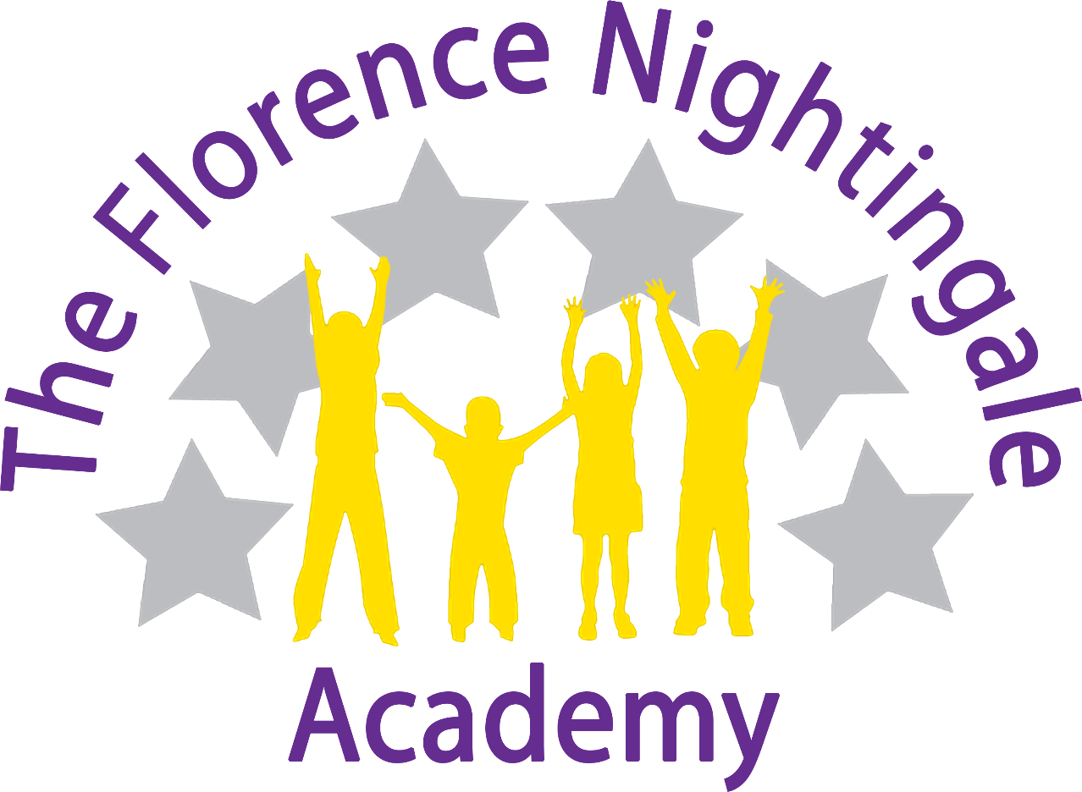
History policy

History Coordinator –
Miss Katie Ridley
Review Date – January 2023

Rationale
At The Florence we are historians! We want our children to love history and for them to have no limits to what their aspirations and ambitions can be. For them to grow up wanting to be archivists, museum curators, archaeologists or research analysts. Through our high-quality history education, we help our children to gain a coherent knowledge and understanding of Britain’s past and that of the wider world. We want to enhance their curiosity and prepare them to ask perceptive questions, think critically, weigh evidence and develop perspective and judgement. We want our children to remember their history lessons in our school, to cherish these memories and embrace the historical opportunities they are presented with!

Introduction
At The Florence we are committed to providing all children with learning opportunities to engage in history. This policy sets out a framework within which teaching and non-teaching staff can work, and gives guidance on planning, teaching and assessment. It has been developed through a process of consultation with school staff and governors.
History is about real people who lived, and real events which happened in the past. History is concerned with sequence, time and chronology and is the study of evidence about the past; it gives us a sense of identity, set within our social, political, cultural and economic relationships. At The Florence, History fires the children’s curiosity about the past in Britain and the wider world and plays an essential part in preparing us for living and working in the contemporary world. Pupils consider how the past influences the present, what past societies were like, how these societies organised their politics, and what beliefs and cultures influenced people’s actions. As they do this, children develop a chronological framework for their knowledge of significant events and people. They see the diversity of human experience, and understand more about themselves as individuals and members of society. What they learn can influence their decisions about personal choices, attitudes and values. In history, children find evidence, weigh it up and reach their own conclusions. To do this they need to be able to research, sift through evidence, and argue for their point of view – skills that are prized in adult life.

Aims
The aims of history are:
- To instil in the children a curiosity and understanding of events, places and people in a variety of times and environments.
- To develop an interest in the past and an appreciation of human achievements and aspirations.
- To understand the values of our society.
- To learn about the major issues and events in the history of our own country and of the world and how these events may have influenced one another.
- To develop a knowledge of chronology within which the children can organise their understanding of the past.
- To understand how the past was different from the present and that people of other times and places may have had different values and attitudes from ours.
- To understand the nature of evidence by emphasising the process of enquiry and by developing the range of skills required to interpret primary and secondary source materials.
- To distinguish between historical facts and the interpretation of those facts.
- To understand that events have a multiplicity of causes and that historical explanation is provisional, debatable and sometimes controversial.

Curriculum
The children undertake a broad and balanced programme following the National curriculum that takes account of abilities, aptitudes and physical, emotional and intellectual development. Through history the children learn a range of skills, concepts, attitudes and methods of working.

Early Years
History is taught in Early Years as an integral part of the topic work through child-initiated and adult led activities. The children are given the opportunity to find out about past and present events in their own lives, and those of their families and other people they know. In the Foundation stage history makes a significant contribution to developing a child’s understanding of the world through activities such as looking at pictures of famous people in history or discovering the meaning of new and old in relation to their own lives.

Key Stage 1
During Key Stage 1, pupils learn about people’s lives and lifestyles. They find out about significant men, women, children and events from the recent and more distant past in Britain and the wider world. They listen, and respond to stories and use sources of information to help them ask and answer questions. They learn how the past is different from the present.

Key Stage 2
During Key Stage 2 pupils learn about significant people, events and places from both recent and more distant past. They learn about change and continuity in their own area, in Britain and in other parts of the world. They look at history in a variety of ways, for example from political, economic, technological and scientific, social, religious, cultural or aesthetic perspectives. They use different sources of information to help them investigate the past both in depth and in overview, using dates and historical vocabulary to describe events, people and developments. They also learn that the past can be represented and interpreted in different ways.
Teaching and Learning
The school uses a variety of teaching and learning styles in history lessons. Our pedagogy is based on research conducted by Rosenshine and his principles of instruction (2012).

History Delivery Document

Intent | We take the National Curriculum statements and provide an enhanced version of this.  We map these in a coherent and sequential progression model that outlines the knowledge, skills and vocabulary needed at each stage that will build to clearly defined end points.  Teachers take the progression grid and map this into a long-term plan for their year group.  Teachers then plan at a more detailed level the sequencing of content to be taught across each unit
Implementation | Ensure that the teachers of the subject have excellent subject knowledge, and leadership supports that acquisition of this for NQT and non- specialist teachers.  Subject matter is presented clearly, teachers carefully check learning and identify misconceptions, providing direct feedback.  Teaching is designed to ensure children know more and remember more. History is carefully resourced to ensure we have all the specialism and resources required.
Impact | Learners develop detailed knowledge and skills. We check this through regular pupil voice and collecting evidence of outcomes which we measure against our age base progression grids. Pupils are well prepared at each stage to be ready for the next stage of learning.

How do ensure that knowledge gained is transferred to working memory into long term memory?
All staff use Rosenshine’s principals in action when planning and delivering lessons.
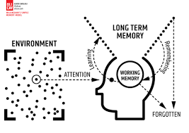
Strategies identified | What do we expect to see in our History lessons?
Regular review | Academic or subject vocabulary that has been taught will be modelled throughout teaching. Teachers will revisit prior knowledge (previous year group/lesson).
Present new materials using small steps | History planning ensures achievable and repeated steps are provided to build children’s confidence, competence and retention.
Ask questions (Blooms taxonomy) | Questions help children practice new information and connect new material to their prior learning. The teacher will question children around the specific knowledge and vocabulary they have using in this topic as well as others.
Provide models | Expert teachers /peer models identified in the lesson will exemplify the specific skills/knowledge required for the task.
Guide student practice | Teachers will spend more time guiding children’s practice of new material. It will be forgotten unless time is given for rehearsal we revisit tasks over and over again, allowing children lots of time to practice. This is always guided and supported by expert teaching.
Check for children’s understanding | Checking understanding at each point can help children learn the material with few errors. We would expect to see tasks/skills broken down into very small chunks, with regular assessment checking from teachers throughout.
Obtain a high success rate | In History, we would expect to see that a skill is successfully taught before moving on. We take our time to achieve consistent success.
Provide scaffolds for difficult tasks | The teacher provides children with temporary supports and scaffolds to assist them when they learn difficult tasks.
Independent practice | Children should have the opportunity to practice regularly and independently to transfer the knowledge into their long-term memory. In History lessons. There is opportunity for this.
Weekly and monthly review | Children need to be involved in extensive practice in order to develop well connected and automatic knowledge. Weekly reviews can take place in History lessons, where teachers return to knowledge learned in a previous unit, and following a period of forgetfulness the children use that knowledge again.

This is supported by the six effective learning strategies (Weinstein and Sumeracki 2019) to ensure that all of our children at The Florence become successful, independent learners who are actively engaged in their own learning.

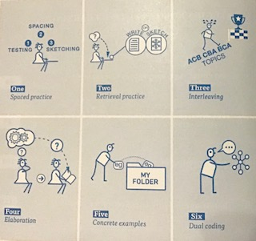

Our principal aim through this pedagogy is to develop the children’s knowledge, skills and understanding in history.
We believe in whole-class teaching methods and combine these with enquiry and skills-based research activities.
We believe children as part of their History curriculum should access a variety of activities in lessons such as:
- They have access to, and are able to handle artefacts
- They go on visits to museums and places of interest
- They have access to secondary sources such as books and photographs
- Visitors talk about personal experiences of the past
- They listen to and interact with stories from the past
- They undertake fieldwork by interviewing family and older friends about changes in their own and other people’s lives
- They use drama and dance to act out historical events
- They are shown, or use independently, resources from the internet and videos
- They are able to use non-fiction books for research
- They are provided with opportunities to work independently or collaboratively, to ask as well as answer historical questions.

We recognise the fact that we have children of differing ability in all our classes, and so we provide suitable learning opportunities for all children by matching the challenge of the task to the ability of the child using our differentiated star challenges. We achieve this through a range of strategies which are differentiated by task, expected outcome and/or support from peers or adults.
Based on combining pedagogy taken from Rosenshine’s principles of instruction and various metacognition strategies History lessons should follow the following structure:
1) Review of prior knowledge e.g. low stake quizzes using knowledge organisers. Can be within the topic or recapping previous history topics covered.

2) Introduce new knowledge and skill for this lesson in small steps taken from Knowledge statement.
-Children may need the new knowledge first
-Then introduce skill/activity
-Model using this skill and applying the knowledge (Your thought processes also)
-Asking questions whilst modelling and lots of discussion
3) Children practise and apply lesson skill.
-Guided practise first (Class modelling and lots of discussion)
-Children apply skill independently (Scaffolding may be required so all children can successfully apply learning)
-Use of AFL and questioning to check student understanding
4) Evaluate and reflect upon the historical skills used to check student understanding.
-How have we been Historians this lesson?
-What has been our new learning this lesson?
-How have we been successful learners?
Additionally, throughout the week in morning registration/before end of day/ lining up to check knowledge from lessons is being retained and transferred in to the long term memory.
Each year group undertakes 3 history topics a year and these are taught in 45 minute weekly sessions for the half term that the topic is being taught.

History curriculum planning
At The Florence, our curriculum is carefully planned to ensure full national curriculum coverage. The topics we have selected are to help strengthen our children’s knowledge of significant individuals and to enable the children to have a deeper understanding of chronology of historical periods and events. Our long-term and medium-term plans map out the skills and themes covered each term for each key stage. These plans define what we will teach and ensure an appropriate balance and distribution of work across each term. Topics are reviewed yearly by the Subject leader liaising with staff and SLT.

Assessment and Recording
At The Florence Nightingale Academy, assessment is an integral part of the teaching process. Assessment is used to inform planning and to facilitate differentiation. The assessment of children’s work is on-going to ensure that understanding is being achieved and that progress is being made. Feedback is given to the children as soon as possible, and marking work will be guided by the school’s marking policy. The knowledge statements are assessed and ticked off on Insight following each lesson. This data is then collated by teachers at the end of each half term to provide children with a level (greater depth, age related, just below, below).

Promoting links with History and Reading
At The Florence, we ensure that we promote a love of reading across all our subjects. We ensure that the children understand how we are always using our reading skills and how this builds on phonic skills taught in EYFS. In our History sessions we access a wide variety of historical texts that children may need to decode and apply the skills taught in our phonics programme. Historical texts also make greater linguistic demands than modern texts: they include vocabulary not used today, and have more complex sentence structures. These texts would then require children to infer meaning of such new vocabulary and leads to an increase in the richness and breadth of children's vocabulary.

Monitoring
Monitoring takes place regularly through sampling children’s work, and teacher planning, through book looks, pupil voice and lesson observations.

Roles and Responsibilities
The subject is led by the staff as a whole and each year time is set aside to review standards and monitor curriculum provision and ensure training and resources are up to date.

Resources
We have a wide range of text books and interactive boards to access the internet as a class. Visits are planned to enhance learning and give hands on activity. People with an interest, or expertise, in a particular topic or area of history could be invited into school to work with the children. These might be parents, grandparents, other family members, neighbours or representatives of the local community.

Curriculum progression
 | EYFS | Year 1 | Year 2 | Year 3 | Year 4 | Year 5 | Year 6
Chronological  Understanding | Pupils should talk about past and present events in their own lives and the lives of family members. | Sequence  objects or  artefacts in age order.  Order personal  events on a  timeline  Then, now,  after, before, a long time ago,before I was born . . . | To sequence objects, events beyond living memory e.g. how technology has changed over time. Horse and Cart to Electric Cars Da Vinci’s Flying Machine to AirBus  Between, past and present | To use both AD  and BC on a  timeline.  Order the  events of  history with the  given dates.  Decade,  Century | To create  specific, closed timelines within a set period of  Time. For instance, the span of the Roman Empire.  Furthermore, a scaled timeline  that includes  dates of a  specific series of events. E.g the Rule of Julius Caesar | To understand  that events in  History can  overlap in  terms of time.  Begin to create  parallel time  lines for time  periods taught.  (8 events) | Draw own  timeline with 2  time periods -  world and  British history.  Compare  changes within  and across  different time  periods.  (10 events)
Knowledge and Understanding of events and people in the past | Pupils should ask and answer questions about their own past using photographs and other prompts. | Pupils should ask and answer questions using stories and other sources. | Pupils should ask and answer questions using stories and other sources to show their understanding of key features and events. | Pupils should describe some of the main events, people and changes. | Pupils should describe some of the main events, people and changes and give reasons for and the consequences for the events and changes. | Pupils should regularly address and sometimes devise questions about change, cause, similarity, difference and significance.  Pupils use this to describe features of past societies, periods and begin to make links between them. | Pupils should regularly address and devise questions about change, cause, similarity, difference and significance.  Pupils use this to describe features of past societies, periods and make links between them.
Historical interpretations | Pupils think about how they can find out about the past. | Extracting  Use sources from within living memory to compare to themselves given books, videos, photos and artefacts to gather information to answer given questions. E.g. photographs of family member as a child compared against their own life. How did people used to dress when your parents were young? | Extracting  Using sources from the past i.e. videos, photos and artefacts to gather information to answer given questions.  E.g. Photograph of planes, automobiles: What were cars like in the past? Pick out the features etc. Interrogating Similarities and differences between given stimulus e.g. photographs showing change E.g. How has transport changed over time? | Extracting  Use 2 or more  different  sources, media  or artefacts to  piece together  information  about a period  of history that is being studied. Recognise the role of archaeologists.  Interrogating & Evaluating  Drawing parallels and bringing together sources to be able to infer what life may have been like. ‘Building up their own interpretation of a period of time | Extracting  Investigate  primary &  secondary  sources and  explain the  differences  between these two types of sources.  Interrogating & Evaluating  Drawing parallels and bringing together sources to be able to infer what life may have been like whilst understand that primary sources hold a greater significance than secondary sources. | Extracting  Investigate and  understand two  different  versions of a  similar event  and compare  and contrast  these.  Interrogating  & Evaluating  Beginning to  understand  source bias.  To comment on  the reliability  and bias of  sources and  how it may  impact the  validity. | Extracting  To be able to  gather  information  from a wide  range of  sources and  select which  sources are most relevant - with varying opinions.  Interrogating & Evaluating  To consider different ways to check and evaluate the reliability of different sources, which may be bias.
Historical enquiry | Pupils should know that some events, people and changes have been interpreted in different ways and suggest possible reasons for this. | Talk about significant events in their own experience (living memory). Ask a ‘what’ question | Look at the objects from the past and ask questions i.e. Look at the objects  from the past and  ask questions i.e. what were they used  for?  How they’ve  changed? | Ask questions –  who, what,  how where,  why.  Find answers in a given extract of text, photographs, and video. Begin to use e-learning to conduct research to answer own questions about an event. | To further  develop the 5  W’s of  Historical questioning and enquiry and ask how questions. E.g. How were the Ancient Greeks similar to the Romans | To develop  questioning  relating to the  cause of historical events and the effects they had. E.g. How did the Spanish effect the Mayan Empire? (Disease, Slavery etc.) | To develop  questioning  relating to the  cause of historical events and the impact they have had. To explain the significance of these events relating them to prior knowledge of the past and present day life. E.g Which society of the past has had the biggest impact on modern British life? Line of enquiry with use of sources and skills previously learned.
Organisation and communication |  |  |  |  |  | Pupils begin to produce structured work, making appropriate use of dates and terms. | Pupils should construct informed responses that involve thoughtful selection and organisation of relevant historical information.

Knowledge statements
Our knowledge statements outline curriculum coverage for each topic and ensure full national curriculum coverage alongside a breadth of knowledge and historical skills.
They contain information of prior curriculum knowledge that the children have learnt throughout their primary curriculum to enable Staff to support the children to make links to their prior knowledge.
Our knowledge organisers also help to show links between historical enquiry through their question approach topic names e.g. How did WW2 change Britain?
All learning objectives are also devised in a question format to structure all lessons to follow an enquiry approach. This allows our children to fully take on the role of a Historian and interpret and interrogate the evidence they are presented with before being able to devise their own well-constructed conclusions to the question lesson focus.
Knowledge statements also outline key vocabulary to be taught within each topic to help address our whole school focus of narrowing the vocabulary gap.

How did WW2 change Britain?
Knowledge to be built upon: | Understanding the world (EYFS) – Children can talk about the past and present events in their own lives.  Inspirational people from the past (Y4, RE) – In this Unit, children look at how they can be inspired by others, and about the ways human courage can make a person an example to others.  Beliefs in action in the world (Y6 RE) – In this unit, children learn about the events of the Holocaust and what we can do to counter-act discrimination and persecution.
Year 6 | Q: What were the main events of WW2?  S: Sequence 10 events on a timeline
Q: How were Jewish people treated in the events leading to WW2?
e.g. Kristallnacht/ Anti-Jewish laws
S: Pupils should regularly address and devise questions about change, cause, similarity, difference and significance.
Q: How significant was the Blitz?
S: Extracting -To be able to gather information from a wide range of sources and select which sources are most relevant - with varying opinions.
Q: What was it like to be an evacuee?
S: Interrogating & evaluating- To consider different ways to check and evaluate the reliability of different sources, which may be bias.
Q: How did WW2 affect Women?
S: S: Extracting -To be able to gather information from a wide range of sources and select which sources are most relevant - with varying opinions.
Q: What was the impact of WW2 on people in our locality?
S: Pupils should construct informed responses that involve thoughtful selection and organisation of relevant historical information.
Key vocabulary | Holocaust, concentration camps, anti-semitism, allies, Luftwaffe, Blitz, VE days, evacuation, blackout, Kristallnacht, air-raid shelter, Nazi.

Knowledge organisers

For students to succeed in a particular area, they must have a foundation of factual knowledge, understand those facts in the context of a conceptual framework and organise knowledge in order to facilitate retrieval and application (Bransford et al., 2000).

At The Florence, we use knowledge organisers to support each topic. Through analysing various studies and research, we want them to support our history curriculum in the following way:

-Allow children at the start of the topic to see the historical learning journey that we will be completing

-Allow children to make links between previous knowledge that links to the new topic we will be undertaking

-Outline key knowledge that will be covered throughout the topic

-Support low-stake quizzes at the start of each lesson through regular retrieval of the information outlined

-Children to refer to them in lessons to support their chronology understanding

-Children to refer to the vocabulary outlined on them to help minimise the vocabulary gap our children encounter

