The Florence Nightingale Academy
Geography policy

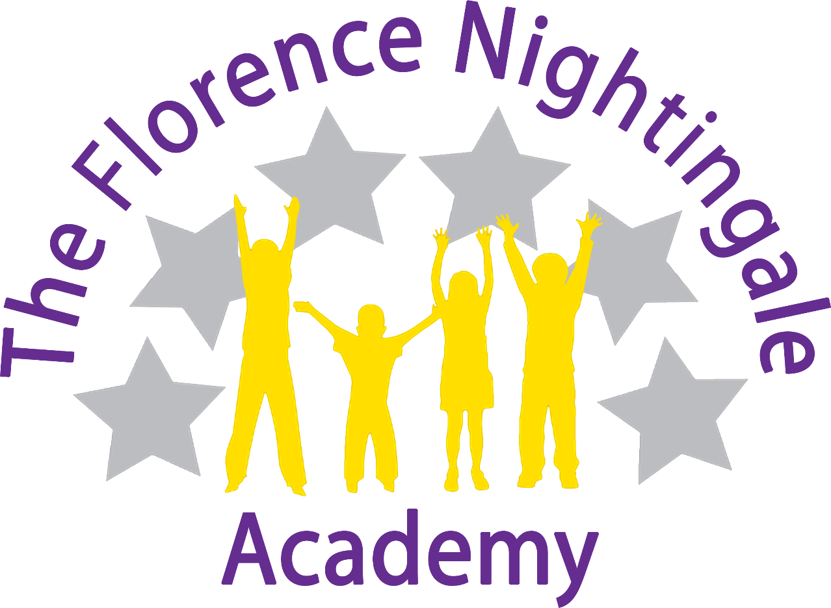

Geography Coordinator –
Miss Katie Ridley
Review Date – September 2022

Rationale
At The Florence Nightingale Academy we are geographers! We want our children to love geography and for them to have no limits to what their aspirations and ambitions can be. For them to grow up wanting to be climate change analysts, geomorphologists, climatologists or even meteorologists. Through our high-quality geography education, we help our children to inspire a curiosity and fascination about the world and its people that will remain with them for the rest of their lives. We hope our pupils will understand how the world is a global stage and they are global citizens on this platform. They will learn how geography plays a big part in politics and the movement of people and goods and how this has shaped our society today. Pupils will be accepting and tolerant of all cultures as they understand the world as one community. We want our children to remember their geography lessons in our school, to cherish these memories and embrace the geographical opportunities they are presented with!

Introduction
At The Florence Nightingale Academy we are committed to providing all children with learning opportunities to engage in geography. This policy sets out a framework within which teaching and non-teaching staff can work, and gives guidance on planning, teaching and assessment. It has been developed through a process of consultation with school staff and governors.

Geography is about inspiring pupils to have a curiosity and fascination about the world and its people that will remain with them for the rest of their lives. Teaching should equip pupils with knowledge about diverse places, people, resources and natural and human environments, together with a deep understanding of the Earth’s key physical and human processes. As pupils progress, their growing knowledge about the world should help them to deepen their understanding of the interaction between physical and human processes, and of the formation and use of landscapes and environments. Geographical knowledge, understanding and skills provide the frameworks and approaches that explain how the Earth’s features at different scales are shaped, interconnected and change over time.

Aims
The aims of geography are:
- To stimulate children’s interest in their surroundings and develop a knowledge and understanding of the physical and human processes which shape places.
- To increase children’s knowledge of other cultures and, in so doing, teach a respect and understanding of what it means to be a positive citizen in a multi-cultural country.
- To provide learning opportunities that enthuse, engage, and motivate children to learn and foster a sense of curiosity and wonder at the beauty of the world around them.
- To encourage in children a commitment to sustainable development and an appreciation of what ‘global citizenship’ means.
- To make sense of their own surroundings through learning about their own locality and the interaction between people and the environment.
- To develop the geographical skills, including how to use, draw and interpret maps of different scales, and the vocabulary necessary to carry out effective geographical enquiry.
- To be able to apply map reading skills to globes and atlas maps and identify geographical features.
- To formulate appropriate questions, develop research skills and evaluate material to inform opinions.
- To enable children to work geographically in a range of appropriate contexts, using a variety of materials and equipment including other people’s experiences and knowledge.

Curriculum
The children undertake a broad and balanced programme following the National curriculum that takes account of abilities, aptitudes and physical, emotional and intellectual development. Through geography the children learn a range of skills, concepts, attitudes and methods of working.

Early Years

Geography is taught in the early years through the specific area of ‘Understanding the World’. We relate the geographical aspects of the children’s work to the objectives set out in the Early Years curriculum. Geography makes a significant contribution to the ELG objectives of developing a child’s understanding of the world through activities such as finding out about different places and habitats and investigating our locality.

Key Stage 1

During Key Stage 1, pupils investigate their local area through fieldwork, observation and discussion. They also learn about a contrasting area in the United Kingdom or abroad, finding out about the environment in both areas and the people who live there. They also begin to learn about the wider world. They carry out geographical enquiry inside and outside the classroom. In doing this, they ask geographical questions about people, places and environments, and use geographical skills and resources, such as maps and photographs.

Key Stage 2
During Key Stage 2, pupils investigate a variety of people, places and environments in the United Kingdom and abroad, and start to make links between different places in the world. They find out how people affect the environment and how they are affected by it. Pupils carry out geographical enquiry inside and outside the classroom. In doing this, they ask geographical questions, and use geographical skills and resources, such as maps, atlases, aerial photographs and ICT. Children will develop geographical enquiry skills, including asking geographical questions, collecting and recording information and identifying different views. They will acquire the appropriate practical skills associated with Geography, including using suitable vocabulary, fieldwork techniques and maps, plans and atlases. Pupils will use secondary sources of information with accuracy, including aerial photographs, satellite images, etc. As well as making its own distinctive contribution to the school curriculum, geography contributes to the wider aims of primary education. Teachers will ensure that links between subjects are maximized.

Teaching and Learning
The school uses a variety of teaching and learning styles in geography lessons. Our pedagogy is based on research conducted by Rosenshine and his principles of instruction (2012).

Geography Delivery Document

Intent | We take the National Curriculum statements and provide any enhanced version of this.  We map these in a coherent and sequential progression model that outlines the knowledge, skills and vocabulary needed at each stage that will build to clearly defined end points.  Teachers take the progression grid and map this into a long-term plan for their year group.  Teachers then plan at a more detailed level the sequencing of content to be taught across each unit
Implementation | Ensure that the teachers of the subject have excellent subject knowledge, and leadership supports that acquisition of this for NQT and non- specialist teachers.  Subject matter is presented clearly, teachers carefully check learning and identify misconceptions, providing direct feedback.  Teaching is designed to ensure children know more and remember more. Geography is carefully resourced to ensure we have all the specialism and resources required.
Impact | Learners develop detailed knowledge and skills. We check this through regular pupil voice and collecting evidence of outcomes which we measure against our age base progression grids. Pupils are well prepared at each stage to be ready for the next stage of learning.

How do we ensure that knowledge gained is transferred to working memory into long term memory?
All staff use Rosenshine’s principals in action when planning and delivering lessons.
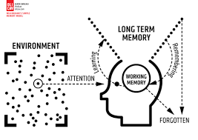
Strategies identified | What do we expect to see in our History lessons?
Regular review | Academic or subject vocabulary that has been taught will be modelled throughout teaching. Teachers will revisit prior knowledge (previous year group/lesson).
Present new materials using small steps | Geography planning ensures achievable and repeated steps are provided to build children’s confidence, competence and retention.
Ask questions (Blooms taxonomy) | Questions help children practice new information and connect new material to their prior learning. The teacher will question children around the specific knowledge and vocabulary they have using in this topic as well as others.
Provide models | Expert teachers /peer models identified in the lesson will exemplify the specific skills/knowledge required for the task.
Guide student practice | Teachers will spend more time guiding children’s practice of new material. It will be forgotten unless time is given for rehearsal we revisit tasks over and over again, allowing children lots of time to practice. This is always guided and supported by expert teaching.
Check for children’s understanding | Checking understanding at each point can help children learn the material with few errors. We would expect to see tasks/skills broken down into very small chunks, with regular assessment checking from teachers throughout.
Obtain a high success rate | In History, we would expect to see that a skill is successfully taught before moving on. We take our time to achieve consistent success.
Provide scaffolds for difficult tasks | The teacher provides children with temporary supports and scaffolds to assist them when they learn difficult tasks.
Independent practice | Children should have the opportunity to practice regularly and independently to transfer the knowledge into their long-term memory. In History lessons. There is opportunity for this.
Weekly and monthly review | Children need to be involved in extensive practice in order to develop well connected and automatic knowledge. Weekly reviews can take place in Geography lessons, where teachers return to knowledge learned in a previous unit, and following a period of forgetfulness the children use that knowledge again.

This is supported by the six effective learning strategies (Weinstein and Sumeracki 2019) to ensure that all of our children at The Florence Nightingale Academy become successful, independent learners who are actively engaged in their own learning.
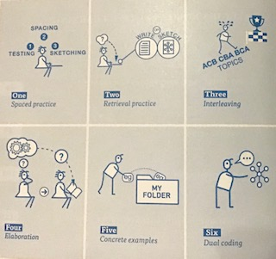

Our principal aim through this pedagogy is to develop the children’s knowledge, skills and understanding in history.
We believe in whole-class teaching methods and combine these with enquiry and skills-based research activities.
We believe children as part of their Geography curriculum should access a variety of activities and experiences such as:
- Visiting landmarks and places of interest
- Using the local environment for fieldwork
- Listening to and engaging with professionals within Geography
- Exploring videos and online resources both as a class and independently
- Uses secondary sources (e.g. non-fiction books) for research
- Taking part in creative activities
- Using a variety of data, such as maps, photographs, statistics, graphs and aerial photographs
- Work independently and collaboratively within class

We recognise the fact that we have children of differing ability in all our classes, and so we provide suitable learning opportunities for all children by matching the challenge of the task to the ability of the child using our differentiated star challenges. We achieve this through a range of strategies which are differentiated by task, expected outcome and/or support from peers or adults.
Based on combining pedagogy taken from Rosenshine’s principles of instruction and various metacognition strategies Geography lessons should follow the following structure:

1) Review of prior knowledge e.g. low stake quizzes using knowledge organisers. Can be within the topic or recapping previous geography topics covered.

2) Introduce new knowledge and skill for this lesson in small steps taken from Knowledge statement.
-Children may need the new knowledge first
-Then introduce skill/activity
-Model using this skill and applying the knowledge (Your thought processes also)
-Asking questions whilst modelling and lots of discussion
3) Children practise and apply lesson skill.
-Guided practise first (Class modelling and lots of discussion)
-Children apply skill independently (Scaffolding may be required so all children can successfully apply learning)
-Use of AFL and questioning to check student understanding
4) Evaluate and reflect upon the geographical skills used to check student understanding.
-How have we been Geographers this lesson?
-What has been our new learning this lesson?
-How have we been successful learners?
Additionally, throughout the week in morning registration/before end of day/ lining up to check knowledge from lessons is being retained and transferred in to the long term memory.
Each year group undertakes 3 geography topics a year and these are taught in 45 minute weekly sessions for the half term that the topic is being taught.

Geography curriculum planning
At The Florence Nightingale Academy, our curriculum is carefully planned to ensure full national curriculum coverage. The topics we have selected are to help strengthen our children’s knowledge and understanding of the world and provide connections with our local area. We use educational visits to enhance the teaching of our subject and provide the children with real life experiences that they may not have the opportunity to access otherwise. Our long-term and medium-term plans map out the skills and themes covered each term for each key stage. These plans define what we will teach and ensure an appropriate balance and distribution of work across each term. Topics are reviewed yearly by the subject leader liaising with staff and SLT.
Assessment and Recording
At The Florence Nightingale Academy, assessment is an integral part of the teaching process. Assessment is used to inform planning and to facilitate differentiation. The assessment of children’s work is on-going to ensure that understanding is being achieved and that progress is being made. Feedback is given to the children as soon as possible, and marking work will be guided by the school’s marking policy. The knowledge statements are assessed and ticked off on Insight following each lesson. This data is then collated by teachers at the end of each half term to provide children with a level (greater depth, age related, just below, below).
Promoting links with Geography and Reading
At The Florence Nightingale Academy, we ensure that we promote a love of reading across all our subjects. We ensure that the children understand how we are always using our reading skills and how this builds on phonic skills taught in EYFS. In our Geography sessions we access a wide variety of non-fiction texts that children may need to decode and apply the skills taught in our phonics programme. Subject specific texts also make greater linguistic demands due to including topic based vocabulary that children may not have accessed previously. These texts would then require children to infer meaning of such new vocabulary and leads to an increase in the richness and breadth of children's vocabulary.

Monitoring
Monitoring takes place regularly through sampling children’s work, and teacher planning, through book looks, pupil voice and lesson observations.

Roles and Responsibilities
The subject is led by the staff as a whole and each year time is set aside to review standards and monitor curriculum provision and ensure training and resources are up to date.

Resources
We have a wide range of text books and interactive boards to access the internet as a class. Visits are planned to enhance learning and give hands on activity. People with an interest, or expertise, in a particular topic or area of geography could be invited into school to work with the children. These might be parents, grandparents, other family members, neighbours or representatives of the local community.
Resources are collated and catalogued yearly by the subject leader. Staff voices also give an indication of further resources that need to be ordered.

Curriculum progression

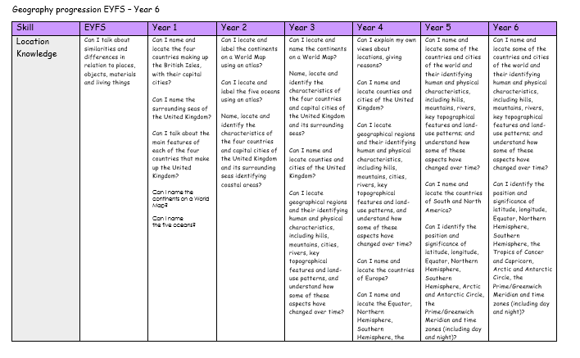

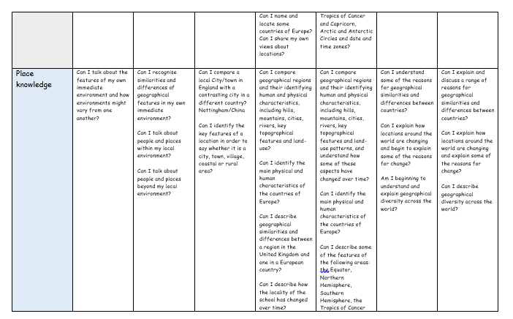

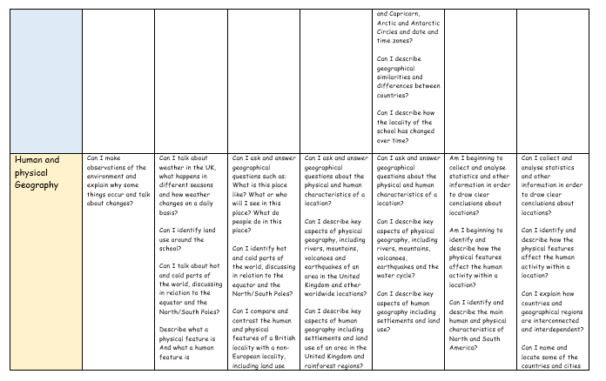
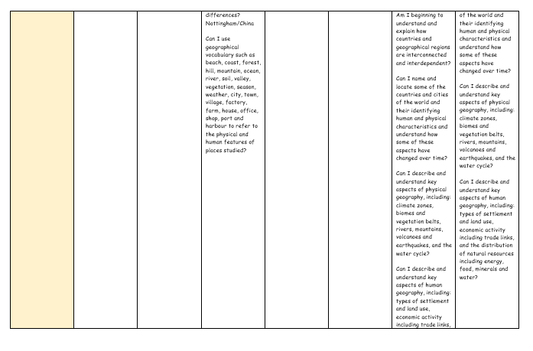
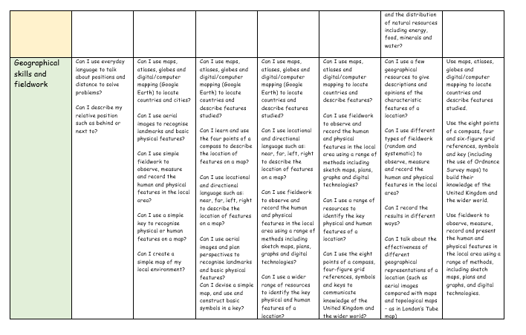

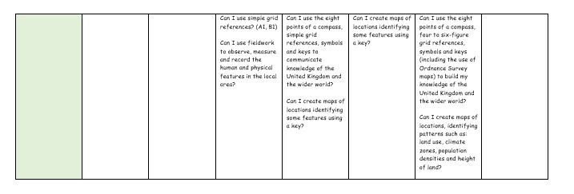

Knowledge statements
Our knowledge statements outline curriculum coverage for each topic and ensure full national curriculum coverage alongside a breadth of knowledge and geographical skills.
They contain information of prior curriculum knowledge that the children have learnt during previous years. This enables staff to plan for and support the children to make links to prior knowledge.
Our knowledge organisers also help to show links between historical enquiry through their question approach topic names.
Knowledge statements also outline key vocabulary to be taught within each topic to help address our whole school focus of narrowing the vocabulary gap.
Knowledge statements are exported onto Insight where teachers can tick them off to track pupil progress.
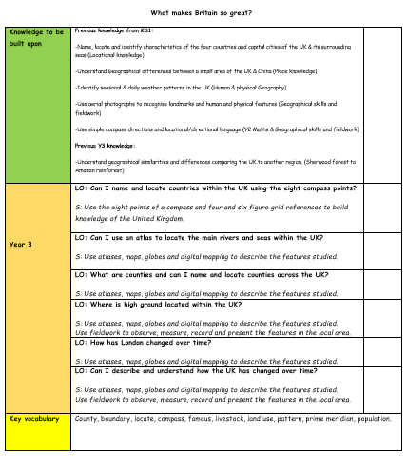

Knowledge organisers

For students to succeed in a particular area, they must have a foundation of factual knowledge, understand those facts in the context of a conceptual framework and organise knowledge in order to facilitate retrieval and application (Bransford et al., 2000).

At The Florence Nightingale Academy, we use knowledge organisers to support each topic. Through analysing various studies and research, we want them to support our geography curriculum in the following way:

-Allow children at the start of the topic to see the geographical learning journey that we will be completing.

-Allow children to make links between previous knowledge that links to the new topic we will be undertaking.

-Outline key knowledge that will be covered throughout the topic.

-Support low-stake quizzes at the start of each lesson through regular retrieval of the information outlined.

-Children to refer to them in lessons to support their understanding.

-Children to refer to the vocabulary outlined on them to help minimise the vocabulary gap our children encounter.
