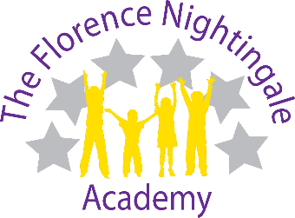

Parent Declaration Form for Checking 30 Hour Eligibility
The information given in this form provides the required written consent from the parent to enable the provider to check the eligibility code for the 30 hour offer.
Providers (the school) must check the parents’ eligibility code before offering the child a 30 Hour Government Funded place.
If a successful check is made and the parent takes up a place with the provider, it is expected that the Parental Consent and Declaration Form are completed and the Terms and Conditions are agreed.
The Local Authority, who administer the codes, may request copies for their auditing purposes.
Provider Name:

Section 1: Child’s Details
Child’s Legal Family Name/Surname: |  | Child’s Legal Forename
Name by which the child is known if different from the above: |  | Child’s Date of Birth
Male/Female: |  | Ethnicity
Full Address: |  | Documentary proof of Date of Birth (e.g. Birth Certificate/ Passport)
Post Code: |  | (For Office Use)
Contact Telephone Number: |  | Date documents are seen and verified
Section 2: Eligibility Proof
30 Hour Eligibility Code:

Parent/Carer National Insurance Number:

Section 3: Parents/Carers Declaration
I agree to The Florence Nightingale Academy validating my eligibility code with the Local Authority
I have read and understand the Terms and Conditions as provided by The Florence Nightingale Academy
Name of parent: (Please print)

Signed: |  | Date:

